Charity Event for the
Trevor Mann Unit and Giggle

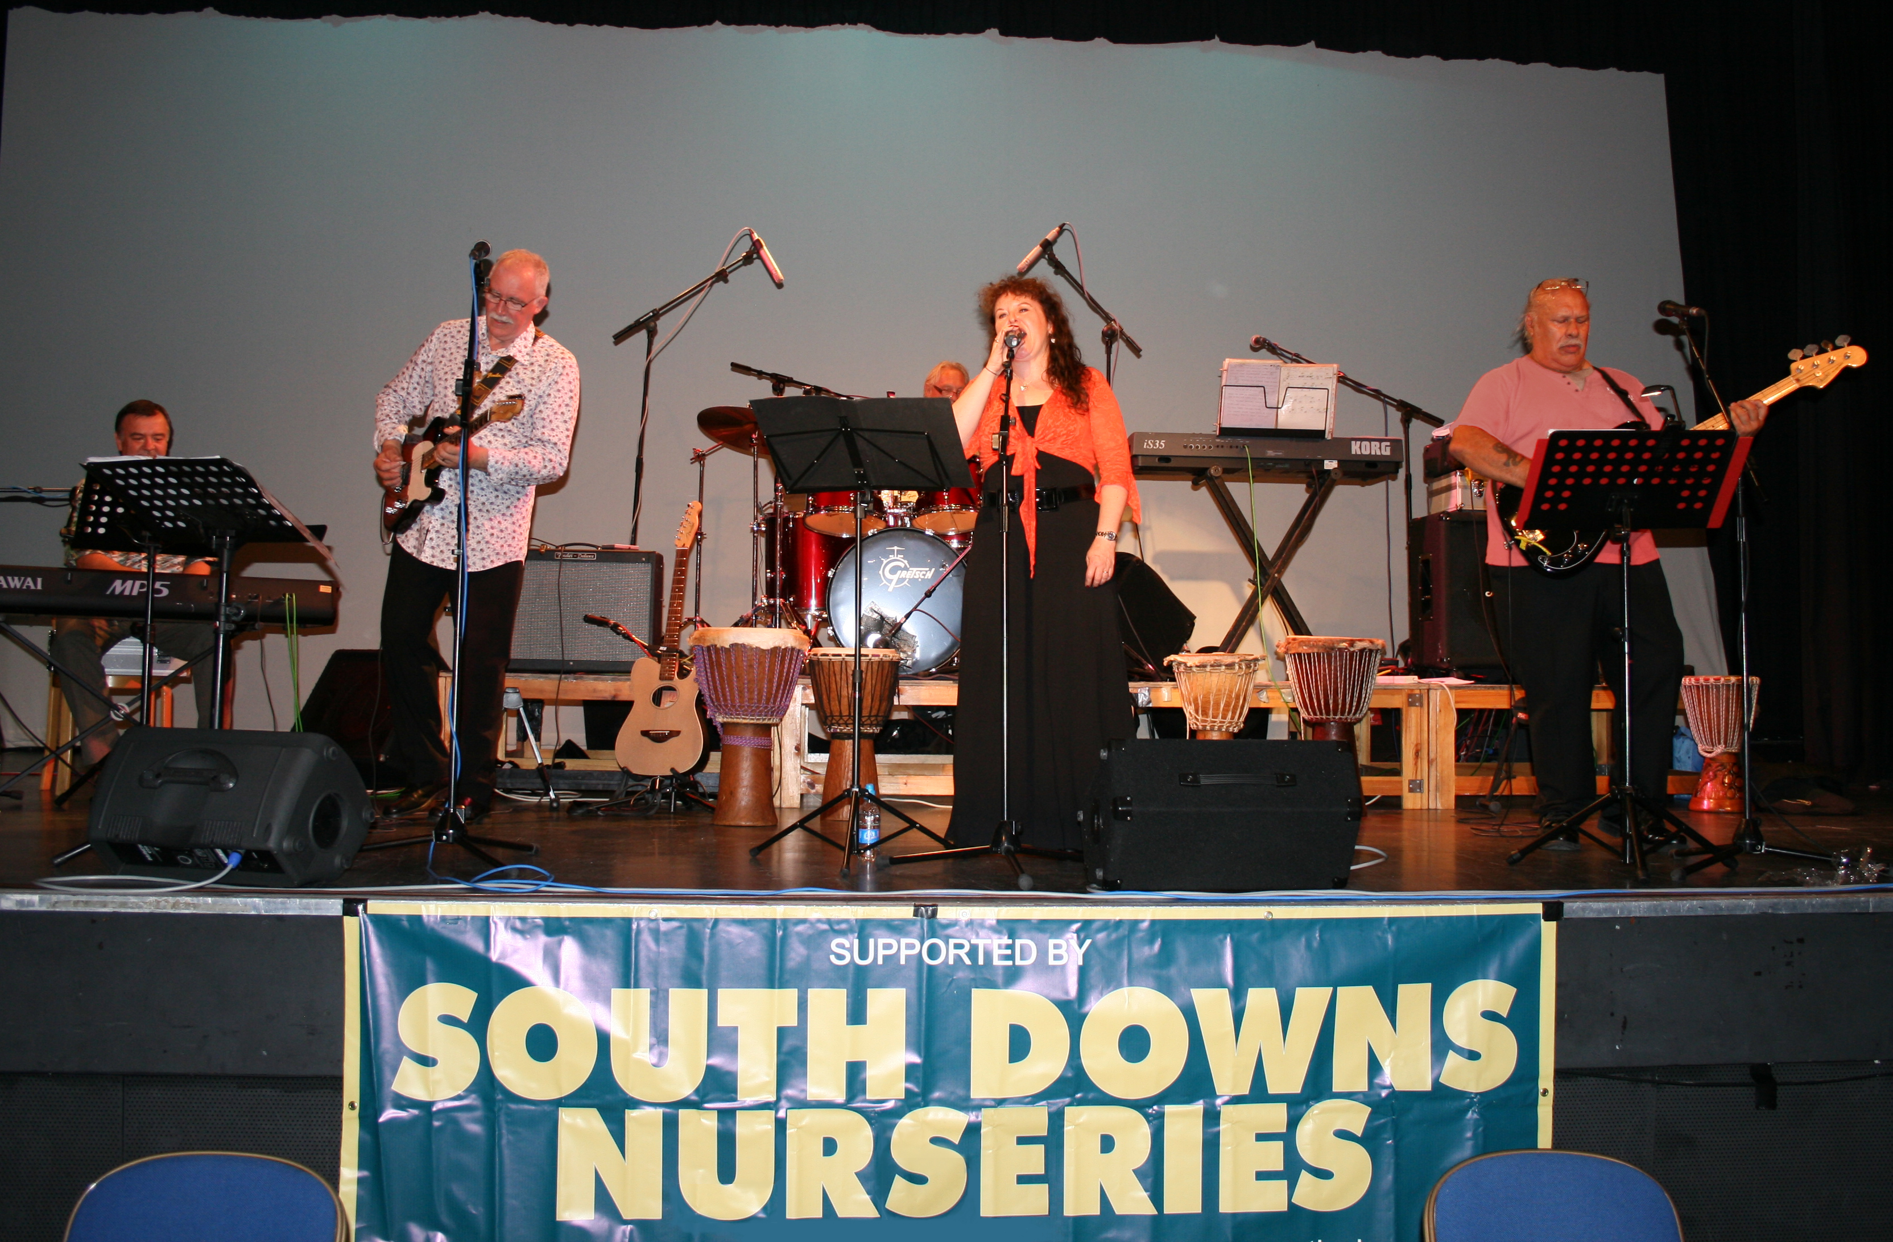

South Downs Nurseries are pleased to announce that we helped raise £1500 from our recent charity event to raise funds for the Trevor Mann Unit and Giggle with assistance from the always amazing Burgess Hillbillies!

Trevor Mann Unit
The Department of Neonatology is based at Trevor Mann Baby Unit (TMBU) at the Royal Sussex County Hospital (RSCH) and provides intensive care treatment for babies in Brighton and across the whole of Sussex.
There are 24 cots on the Baby Unit, of which 14 are specially designated to look after the sickest babies and 10 for those recovering. In 2008 there were 524 admissions to TMBU, with 273 babies requiring full intensive care treatment. 114 babies weighing less than 1500g at birth were admitted and of these 56 were more than three months premature.

One in five of all admissions are babies born in hospitals outside Brighton, often our occupancy is very high, making admission of new babies difficult. There are 24 cots on the TMBU, including 8 designated for intensive care, 6 for high dependency care and 10 for special care. Expansion and refurbishment of the Unit was completed in May 2008 with an immediate increase of 3 cots.
We continue to rely on charity donations to help us equip our Unit to the highest standard.

Giggle

Giggle is a theatre / creative group in Burgess Hill
for those of all ages (currently from age 7 to 62 !! )
Where those who have mental and physical disadvantages can come and discover, develop and nurture their creative gifts and can learn more about their unique creative fingerprint that can bless the world they live in and the people they meet.

